NGO Gallery – Photo Titles (Batch 3)
Photos 41–60 · short English titles for the gallery page
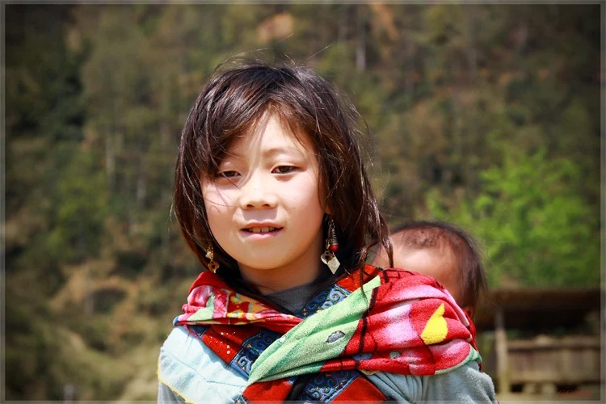  41 Gentle Strength  be-vung-cao5-giaoduc_net_vn.webp | 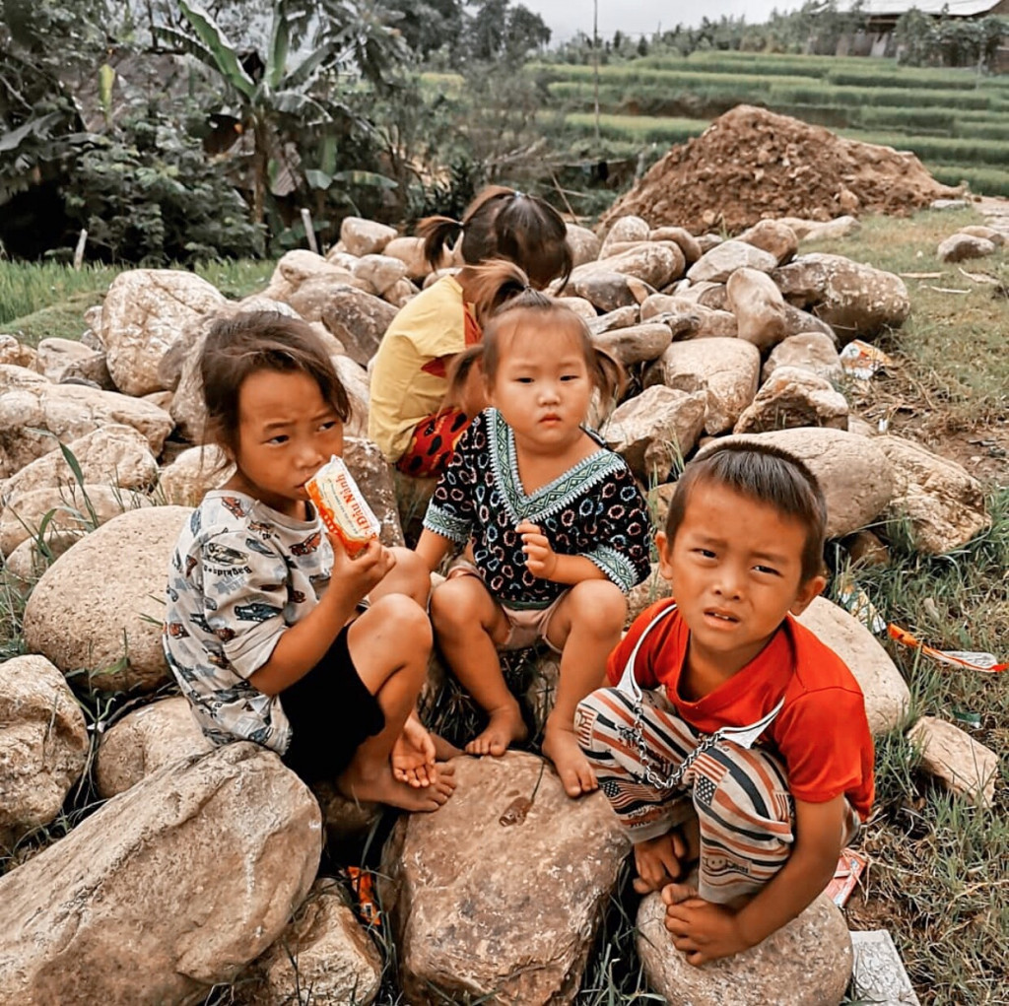  42 Little Ones, Big Needs  cd3f356dd30889924aecee61ffbe28a6.jpg
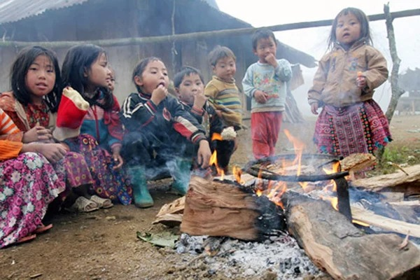  43 Warmth Shared  f5a888d5-ec43-45da-b6a3-00abac927e9b.webp | 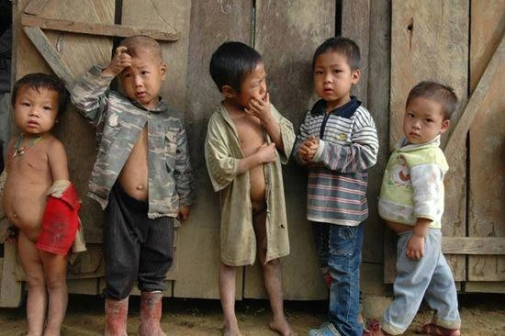  44 Side by Side  gop-suc-vi-tre-vung-cao-viec-dau-qua-tam-tay.webp
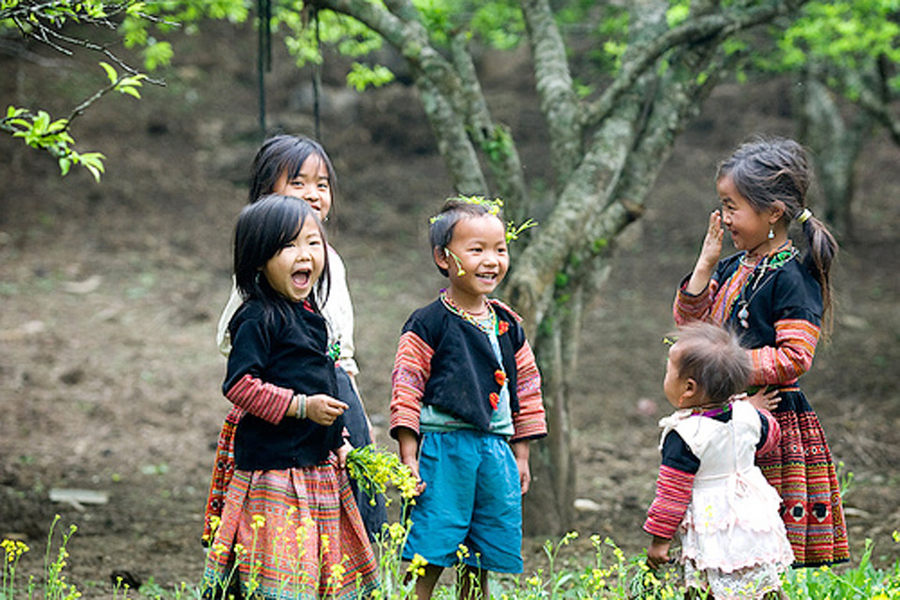  45 Wildflower Laughter  hinh-anh-cuoc-song-hon-nhien-cua-tre-em-vung-cao-1.jpg | 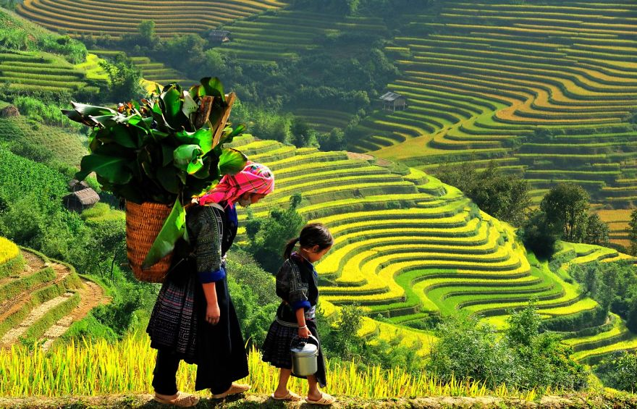  46 Golden Steps Together  man-nhan-truoc-ve-dep-tinh-khoi-vung-cao-viet-nam__1_.jpg
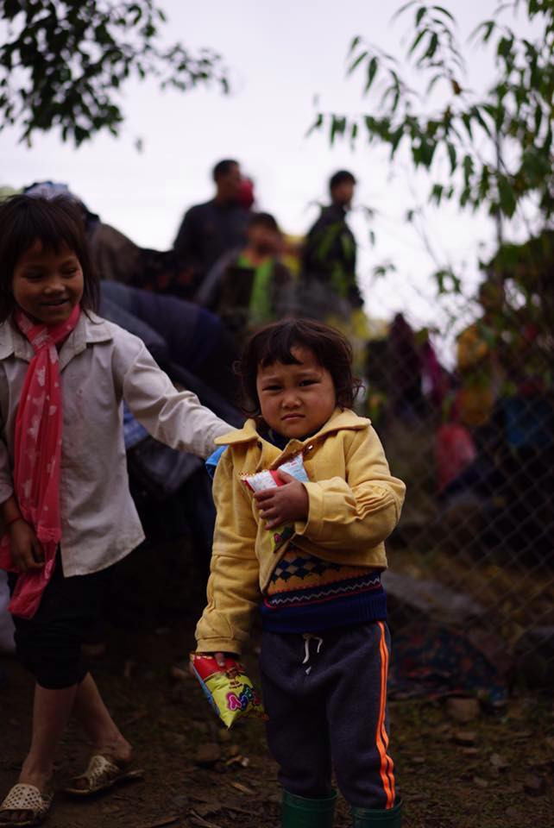  47 A Gift in Small Hands  nguoihanoi-com-vn-1-26-.jpg | 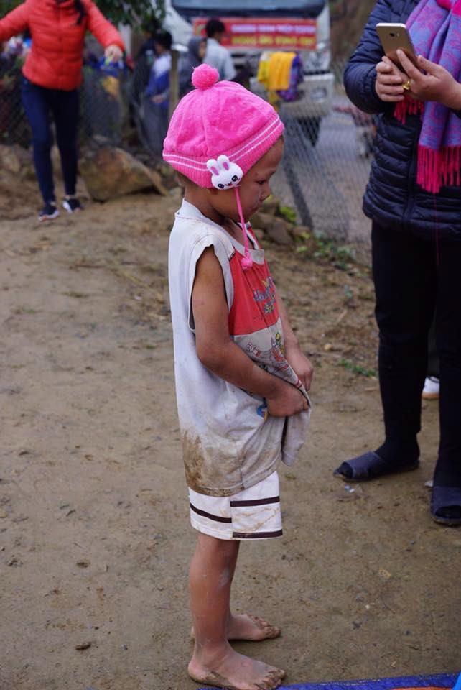  48 Waiting Quietly  nguoihanoi-com-vn-2-24-.jpg
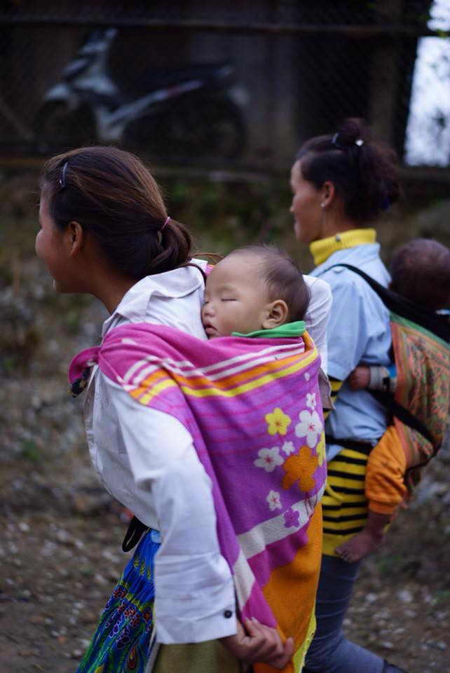  49 Sleeping Safe on Her Back  nguoihanoi-com-vn-5-16-.jpg | 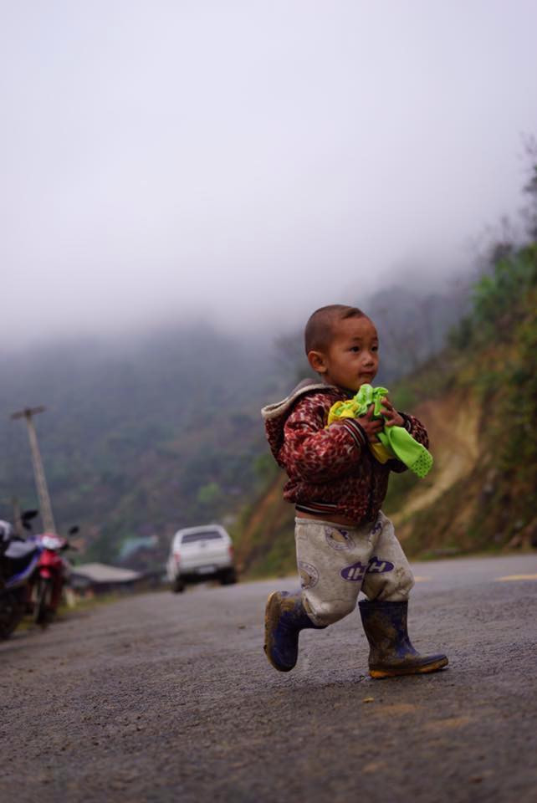  50 Running Through the Mist  nguoihanoi-com-vn-6-6-.jpg
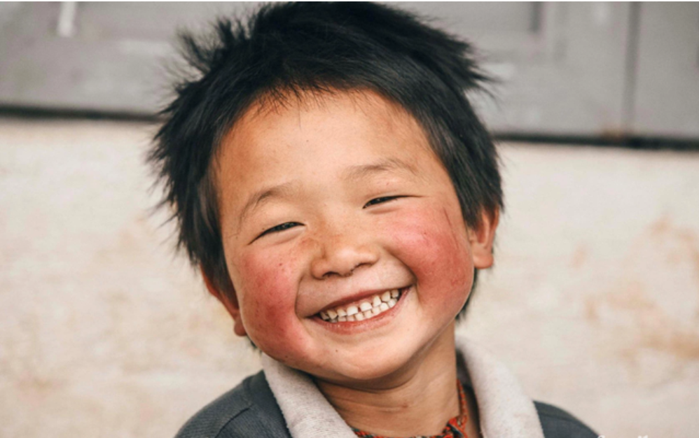  51 Rosy Cheeks, Big Smile  Screenshot_2026-09-29_011426.png | 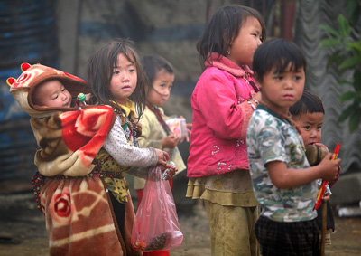  52 Little Guardians  tre-em-vung-cao-mua-ret-1.jpg
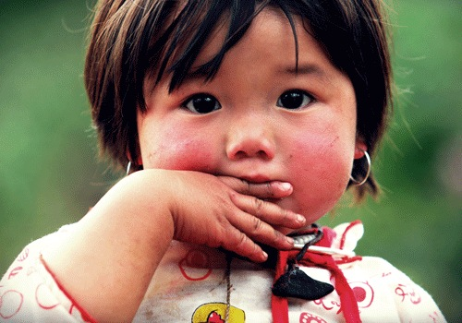  53 Innocent Eyes  tre-em-vung-cao-mua-ret-4.gif | 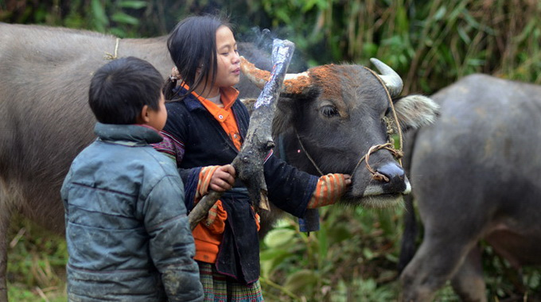  54 Little Farmhands  tre-em-vung-cao-mua-ret-5.jpg
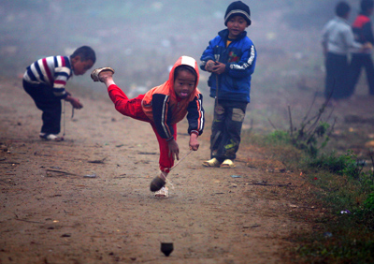
55 Play Finds a Way
tre-em-vung-cao-mua-ret-8.jpg
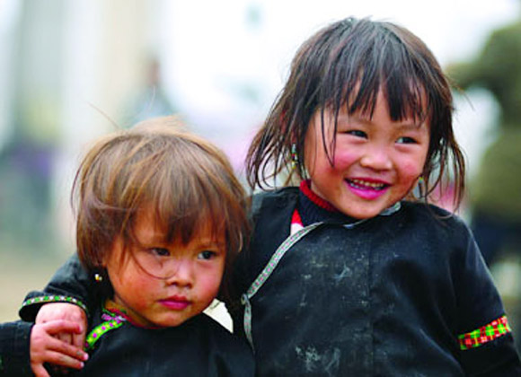  57 Comfort in Friendship  tre-em-vung-cao-mua-ret-11.jpg | 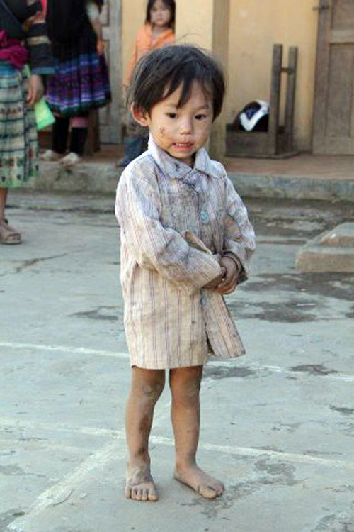  58 Small Feet, Cold Ground  tre-em-vung-cao-mua-ret-13.jpg
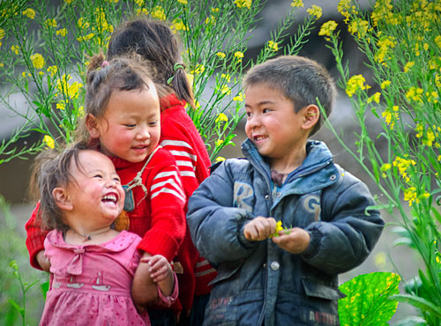  59 Joy in Bloom  tre-em-vung-cao-mua-ret-18.jpg | 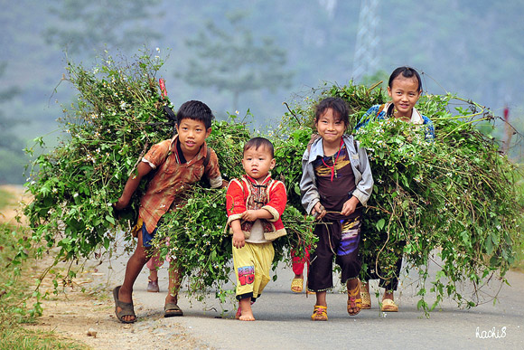  60 Small Backs, Big Loads  tre-em-vung-cao-mua-ret-19.jpg

